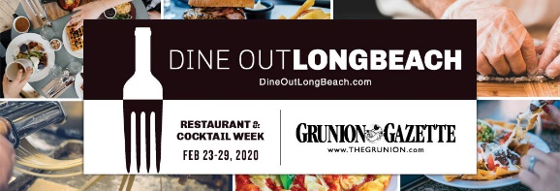
FIRST COURSE
BO- Beau’s Famous Brussels Sprouts
house-cured pancetta + parmesan cheese + balsamic glaze
or
Tomato Bisque
crème fraiche + chives GF
or
Wedge Salad
Bibb lettuce + crispy pancetta + tomato +shaved red onion + bleu cheese dressing

SECOND COURSE
Beef Bourguignon
short rib + roasted baby carrots + mashed potatoes
Chicken Fricassee
roasted potato + pickled mustard seeds + zucchini + mustard sauce GF
Ratatouille
roasted eggplant + zucchini + squash + oven-roasted tomato + Pomodoro sauce GF V
THIRD COURSE
Banana Bread Pudding
Croissant + vanilla ice cream + bananas + crème anglaise + candied pecans
Blueberry Cheesecake
$40 per person plus tax & gratuity
Please call 562.983.0056 for reservations
A 4% surcharge will be added to all Guest checks to help cover increasing costs and in our support of the recent increases to minimum wage and benefits for our dedicated Team Members.

