Restaurant Week Menu
$30
Three- Course Meal
Appetizer
Choose one:
Bison Chili
Soup of the Day
Garden or Caesar Salad
Entrée
Choose one:
BBQ or Roasted Chicken
Beef Brisket
Pulled Pork
Texas Hot Link
Catfish
Rib Tips
1/3 Slab St Louis Ribs
Dessert
Choose one:
Bread Pudding
Banana Pudding
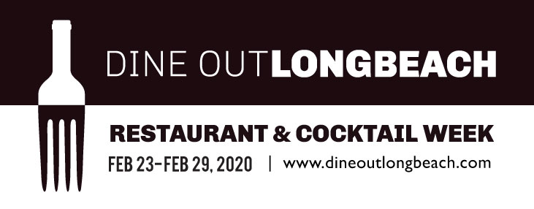
$50
Three- Course Meal For Two
Appetizer
Choose two:
Bison Chili
Soup of the Day
Garden or Caesar Salad
Entrée
Choose two:
BBQ or Roasted Chicken
Beef Brisket
Pulled Pork
Texas Hot Link
Catfish
Rib Tips
1/3 Slab St Louis Ribs
Dessert
Choose two:
Bread Pudding
Banana Pudding

